**MIS 6326**

**Database Management**

**YogurtVille**

**Database Management System**



Contents

Introduction 4

Company Overview 4

Problems in the current system 5

Database Scope and Table Description 6

Inventory Table 6

Item Table 6

Inventory_Item Table 6

Sales Table 6

Order_sales_line Table 7

Employee Table 7

Fulltime_Employee Table 7

Dependents Table 7

Parttime_Employee Table 8

Supplier Table 8

Inventory_Supplier Table 8

Entity Relationship Diagram 9

Relational Database Schema 10

Inventory Table 10

Item Table 10

Inventory_Item Table 10

Sales Table 10

Order_sales_line Table 11

Employee Table 11

Fulltime_Employee Table 11

Dependents Table 11

Parttime_Employee Table 12

Supplier Table 12

Inventory_Supplier Table 12

Menu and Data Input Forms 13

Form Menu 13

Item Details Form 13

Fulltime Employees Form 14

Part time Employees Form 14

Raw Material Form 15

Supplier Information Form 15

Invoice Information Form 16

Report Menu 16

Sample Reports 17

Product Nutritional Value report 17

Raw Material report 18

Raw Material Invoice by Date report 19

Raw Material by Supplier report 20

Sales Details by Date report 22

Sales by Employee report 23

Sales by Month and Year report 25

Contributions 27

# Introduction

## Company Overview

YogurtVille is a frozen yogurt parlor that was started in Austin in July, 2013, Texas and is locally owned and operated.

The parlor offers the finest quality of frozen yogurt in a variety of flavors like Blueberry Tart, Sunny Orange Sorbet, Butterfinger etc. It also offers a large assortment of delightful toppings; fruit toppings like Strawberry, Kiwi, Lychee, Pomegranate etc. that are cut daily to ensure quality and freshness and dry toppings like Walnuts, Chocolate Chips, Gummy Bears, Oreo Cookies etc.

The parlor specializing in exquisite yogurt flavors has their own yogurt recipes and locally prepares the yogurt. The toppings are bought from suppliers directly. In order to maintain raw material cost low and to reduce lead time, YogurtVille maintains deep relationship with a network of suppliers. To reduce excessive dependency on any one supplier at any point of time, YogurtVille deals with multiple suppliers for most raw materials. It approaches a supplier with its requirement and based on Supplier’s quotation, lead time and their terms and conditions, fixes the supplier for an order of raw material. After establishing a relationship with a supplier, the supplier is assigned a rating based on their performance with the orders.

Besides, the owner, the parlor currently has full-time salaried employees and part-time employees who are paid an hourly wage rate. Each new employee; both full-time and part-time is assigned a supervisor to whom he/she reports to, within the first two weeks of starting the job. The Supervisor is generally a senior employee who is responsible for training and mentoring the employees assigned to him. A supervisor can have more than 1 employee as a mentee. However every employee need not have a supervisor. YogurtVille also provides medical insurance coverage to its salaried employees and their dependents.

YogurtVille sells yogurt and toppings by ounces and has fixed the prices of the items by the same unit of measurement. It buys raw materials from the suppliers by pounds. The parlor also provides seasonal discounts and also a discount to customers who check-in to YogurtVille on Yelp.

YogurtVille, being situated in the Domain Drive complex in Austin with a number of apartments, condominium and companies like IBM in the vicinity, enjoys a loyal customer base. The current process of entering, maintaining and retrieving data is a mix of manual - paper and excel sheet based.

However, with stores like Dicks Sporting Goods and Farmers Market opening in the area in last 5 months, YogurtVille has witnessed a huge growth in its business. With its commitment towards excellence and customer satisfaction, the parlor has undergone a menu revamp 2 months ago. It also has plans to keep re-inventing itself with new yogurt flavors based on customer feedback.

The employees of YogurtVille now feel overburdened to manually maintain all data – sales, inventory, products, raw material etc. It takes around 3 man hours per day to enter sales data, update inventory data etc. which is proving to be an expensive and time consuming ordeal.

Thus, it is now the appropriate time for YogurtVille to move from manual paper and excel based system to an electronic database. A database would ensure a stable, efficient and error free platform to store, maintain and retrieve data. As a database is scalable in nature, it would support all future growth of the parlor.

## Problems in the current system

* Time-consuming
* Error-prone as manually managed
* Difficult to keep a check on the inventory and determine when to place new orders for raw material
* Difficult to retrieve sales data and Invoice data as per requirement
* The current paper and excel sheet system of maintaining data is not standardized and is largely dependent on the skill, memory and knowledge about the existing ‘way of data storage’ of the employees handling the system. It is thus required to train a new employee before he/she can use the current system.
* As the current system uses a mix of paper and excel sheet, the data is compartmentalized and stored in 2 different media which is difficult to manage and inter-relate

# Database Scope and Table Description

As this business is currently expanding, the main portion of the database is the inventory management system and the Sales system. Employee is the only authorized person to add/edit data values in the database. The database stores and maintains daily sales transaction. In addition to this, it also maintains information about different items which are available to be sold in the store, employee information, supplier information and also raw material information. It allows the business to maintain invoices of the transactions with the suppliers, track employees and monitor inventory and raw material purchases and maintain sales history. The business database has 11 tables.

## Inventory Table

This table contains information about the raw material inventory. As this is a product based business maintaining inventory is one of the important factor of the database. Each inventory has various attributes namely: 1. Raw Material ID as Raw_mat_id, 2. Raw Material Name as Raw_mat_name, 3. Quantity in hand as Qty_in_hand 4. Minimum Order Quantity or the minimum quantity of the raw material that needs to be maintained in the inventory without ordering a new supply as Min_order_qty. Each row is uniquely identified with Raw_mat_id which is a Primary Key for this table.

## Item Table

This table contains information about various items the business is selling. It contains information about each item in the menu which the store is selling, description of the item, item category and unit price i.e. price of the item per ounce. It also has nutritional information about each item and records the calorie count, protein, carbohydrates and sugar contained in per ounce of each item. This table has eight attributes namely: 1. Item Number as Item_no, 2. Item Name as Item_name, 3. Item Description as Item_desc, 4. Number of Calorie as Calorie_count, 5. Amount of Protein as Protein, 6. Sugar Content as Sugar, 7. Carbohydrates amount as Carbohydrates 8. Price per unit of item as Item_unit_price. Each row of the table is uniquely identified by Item_no which is the primary key of this table.

## Inventory_Item Table

As each Item can be made of multiple raw materials and each raw material can be used to make many items, there exists a Many to Many relationship between Inventory and Item tables. Hence, we introduced a third table, Inv_Item, which maps items to raw material and converts the many-to-many relationship to 2 One to Many relationships. There are only two attributes in this table, which are: 1. A unique identification number of Raw Material as Raw_mat_id, 2. Unique Identification number of Item as Item_no. In this table both the attributes together act as the Primary keys and are also the Foreign Keys. The foreign keys refer to primary key Item_no in the Item table and primary key Raw_mat_id in the Inventory table.

## Sales Table

This table contains information about daily sales transaction. It also stores information about promotional discounts used by customers in every transaction, if any. The attributes are as follows: 1. Sales identification number as Sales_no, 2. Identification for the employee who handled the particular sale as Emp_id, 3. Date of sales transaction as Sales_date, 4. Marketing or promotional discount as Discount. Sales_no is a designated primary key for this table. Emp_id is the foreign key referencing Employee table.

## Order_sales_line Table

As each Item (items are not individuated) can be a part of many sales transactions and each sale can have many items, there exists a Many to Many relationship between Item and Sales table. Hence we have introduced a third table, Sales_Line, between them to convert this relationship into 2 One to Many relationships. This table contains information about the Item purchased in any particular sales transaction along with the Quantity purchased by customer. The attributes are: 1. A unique identification number of Item as Item_id, 2. Unique identification of the sales transaction as Sales_no, 3. Total quantity purchased by customer as Qty. In this table, Item_id and Sales_no together form the Primary Key. These attributes are also Foreign Keys referencing other tables. Item_id references Item table’s Primary Key and Sales_no references Sales table’s primary key.

## Employee Table

This table contains basic information about employee. It has various attributes namely: 1. Employee identification number as Emp_id, 2. First Name of employee as Emp_Fname, 3. Last Name of the employee as Emp_lname, 4. Street Address as Emp_street, 5. Employee City as Emp_city, 6. Employee state as Emp_state, 7. Zip code of employee address as Emp_zip, 8. Employee phone number as Emp_phone, 9. Employee ID of the supervisor as Emp_Supervisor, 10. Types of employee i.e. full time or part time as Emp_Type. Each row is uniquely identified by Emp_id which is a primary key of the table.

There are two types of employees in this business namely Full time employees and Part time employees, which make a generalized hierarchy relationship with Employee table as the Supertype and the Full time employees and Part time employees tables as Subtypes.

### Fulltime_Employee Table

This business provides Insurance coverage to its Full time employees and their dependents. Hence, this table has information about insurance coverage and monthly salary of the employees. The attributes are: 1. Employee identification number as Emp_id which is a foreign key referencing Employee table, 2. Fixed monthly salary of employee as Emp_salary, 3. Insurance coverage amount for each employee as Emp_Ins_coverage

### Dependents Table

This table is maintained to capture information of the dependent members of those employees who have insurance coverage. The attributes are: 1. Identification number for the dependents as Dep_no, 2. Identification number of the employee whose dependents information is being captured as Emp_id, 3. First Name of the Dependent as Dep_fname, 4. Last name of the dependent as Dep_lname. The attribute Emp_id is a Foreign key referencing Fulltime_Employee table. The Dep_id and Emp_id together make the composite Primary Key for this table.

### Parttime_Employee Table

This table contains information about hourly wage rates and hours worked per day by part time employee. Attributes are: 1. Employee identification number for each employee as Emp_id, 2. Wages of part time employees as Emp_hourly_rate, 3. Information about hours worked per day as Emp_hrs_per_day

## Supplier Table

This table maintains information of all the suppliers of the raw material. It contains basic information along with their ratings and lead time. It has different attributes like 1. Supplier identification number as Sup_id, 2. Supplier’s first name as Sup_fname, 3.Supplier’s last name as Sup_lname 4. Street address of supplier as Sup_street, 5. City of Supplier as Sup_city, 6. Supplier’s address Zipcode as Sup_zip, 7. Phone number of Supplier as Sup_phone, 8. Supplier Lead Time as Sup_lead_time, 9. Rating reviews of Supplier as Sup_rating. Sup_id is the primary key and identifies all the rows of the table.

## Inventory_Supplier Table

As each supplier can supply more than 1 type of raw material and each raw material can be supplied by multiple suppliers, there exists a Many to Many relationship between Inventory and Supplier table. Thus, we have introduced this table to convert the Many to Many relationship to 2 One to Many relationships. This table basically captures each sales transaction between a supplier and YogurtVille for a raw material. The table gives information about Raw material being purchased, the Supplier from whom the raw material is purchased, quantity of the raw material purchased and which employee is handling this transaction. This table’s attributes are as follows: 1. Transaction identification number as Invoice_id, 2. Quantity of raw material purchased as Qty_purchased, 3. Price of raw material charged by the supplier as Raw_mat_price_per_unit, 4. Raw material identification number purchased as Raw_mat_id, which is a Foreign Key referencing Inventory Table, 5. Supplier identification number who supplies the raw material as Sup_id, this is also a Foreign Key referencing Supplier table, 6. Employee identification number who takes care of the transaction as Emp_id, this is a foreign key referencing Employee table, 7. Date of purchase of raw material as Invoice_date.

# Entity Relationship Diagram



# Relational Database Schema

## Inventory Table

CREATE TABLE Inventory

(Raw_mat_id CHAR (10) NOT NULL,

Raw_mat_name VARCHAR (30) NOT NULL,

Min_order_qty INT NOT NULL,

Qty_in_hand DECIMAL (3, 2) NOT NULL,

CONSTRAINT Inventory_PK PRIMARY KEY (Raw_mat_id))

## Item Table

CREATE TABLE Item

(Item_no CHAR (5) NOT NULL,

Item_name VARCHAR (30) NOT NULL,

Item_desc VARCHAR (50),

Calorie_count NUMBER,

Protein NUMBER,

Sugar NUMBER,

Carbohydrates NUMBER,

Item_unit_price DECIMAL (3, 2) NOT NULL,

CONSTRAINT Item_PK PRIMARY KEY (Item_no))

## Inventory_Item Table

CREATE TABLE Inventory_Item

(Item_no CHAR (5) NOT NULL,

Raw_mat_id CHAR (10) NOT NULL,

CONSTRAINT Inventory_Item_PK PRIMARY KEY (Raw_mat_id, Item_no),

CONSTRAINT Inventory_Item_FK1 FOREIGN KEY (Raw_mat_id) REFERENCES Inventory,

CONSTRAINT Inventory_Item_FK2 FOREIGN KEY (Item_no) REFERENCES Item)

## Sales Table

CREATE TABLE Sales

(Sales_no CHAR (5) NOT NULL,

Sales_date DATETIME NOT NULL,

Emp_id CHAR (5) NOT NULL,

Discount DECIMAL (2, 2),

CONSTRAINT Sales_PK PRIMARY KEY (Sales_no),

CONSTRAINT Sales_Employee_FK FOREIGN KEY (Emp_id) REFERENCES Employee)

## Order_sales_line Table

CREATE TABLE Order_sales_line

(Item_no CHAR (5) NOT NULL,

Sales_no CHAR (5) NOT NULL,

Qty INT NOT NULL,

CONSTRAINT Order_Sales_PK PRIMARY KEY (Sales_no, Item_no),

CONSTRAINT Order_Sales_FK1 FOREIGN KEY (Sales_no) REFERENCES Sales,

CONSTRAINT Order_Sales_FK2 FOREIGN KEY (Item_no) REFERENCES Item)

## Employee Table

CREATE TABLE Employee

(Emp_id CHAR (5) NOT NULL,

Emp_fname VARCHAR (30) NOT NULL,

Emp_lname VARCHAR (30) NOT NULL,

Emp_street VARCHAR (30) NOT NULL,

Emp_city VARCHAR (30) NOT NULL,

Emp_state VARCHAR (30) NOT NULL,

Emp_Zip VARCHAR (10) NOT NULL,

Emp_phone CHAR (10) NOT NULL,

Emp_supervisor CHAR (5) NOT NULL,

Emp_type CHAR (3) NOT NULL,

CONSTRAINT Employee_PK PRIMARY KEY (Emp_id),

CONSTRAINT Employee_Mgr_FK1 FOREIGN KEY (Emp_id) REFERENCES Employee)

### Fulltime_Employee Table

CREATE TABLE Fulltime_Employee

(Emp_id CHAR (5) NOT NULL,

Emp_salary DECIMAL (10, 2) NOT NULL,

Emp_Ins_coverage DECIMAL (2, 2) NOT NULL,

CONSTRAINT Fulltime_Employee_PK PRIMARY KEY (Emp_id),

CONSTRAINT Fulltime_Employee_FK FOREIGN KEY (Emp_id) REFERENCES Employee)

### Dependents Table

CREATE TABLE Dependents

(Dep_no CHAR (5) NOT NULL,

Emp_id CHAR (5) NOT NULL,

Dep_fname VARCHAR (30) NOT NULL,

Dep_lname VARCHAR (30) NOT NULL,

CONSTRAINT Dep_Employee_PK PRIMARY KEY (Emp_id, Dep_no),

CONSTRAINT Dependent_Employee_FK FOREIGN KEY (Emp_id) REFERENCES FULLTIME_EMPLOYEE)

### Parttime_Employee Table

CREATE TABLE Parttime_Employee

(Emp_id CHAR (5) NOT NULL,

Emp_hourly_rate DECIMAL (5, 2) NOT NULL,

Emp_hrs_per_day DECIMAL (3, 2) NOT NULL,

CONSTRAINT Parttime_Employee_PK PRIMARY KEY (Emp_id),

CONSTRAINT Parttime_Employee_FK FOREIGN KEY (Emp_id) REFERENCES Employee)

## Supplier Table

CREATE TABLE Supplier

(Sup_id CHAR (5) NOT NULL,

Sup _fname VARCHAR (30) NOT NULL,

Sup _lname VARCHAR (30) NOT NULL,

Sup _street VARCHAR (30) NOT NULL,

Sup _city VARCHAR (30) NOT NULL,

Sup _state VARCHAR (30) NOT NULL,

Sup _zip VARCHAR (10) NOT NULL,

Sup _phone CHAR (10) NOT NULL,

Sup_lead_time DECIMAL (5, 2) NOT NULL,

Sup_rating CHAR (5),

CONSTRAINT Supplier_PK PRIMARY KEY (Sup_id))

## Inventory_Supplier Table

CREATE TABLE Inventory_Supplier

(Invoice_id CHAR (10) NOT NULL,

Raw_mat_id CHAR (10) NOT NULL,

Sup_id CHAR (5) NOT NULL,

Qty_purchased INT NOT NULL,

Raw_mat_price_per_unit DECIMAL (3, 2) NOT NULL,

Emp_id CHAR (5) NOT NULL,

Invoice_date DATETIME NOT NULL,

CONSTRAINT Inventory_Sup_PK PRIMARY KEY (Invoice_id),

CONSTRAINT Inventory_Sup_FK1 FOREIGN KEY (Raw_mat_id) REFERENCES Inventory,

CONSTRAINT Inventory_Sup_FK2 FOREIGN KEY (Sup_id) REFERENCES Supplier,

CONSTRAINT Inv_Emp_FK2 FOREIGN KEY (Emp_id) REFERENCES Employee)

# Menu and Data Input Forms

## Form Menu

Main screen for navigation to all the input forms

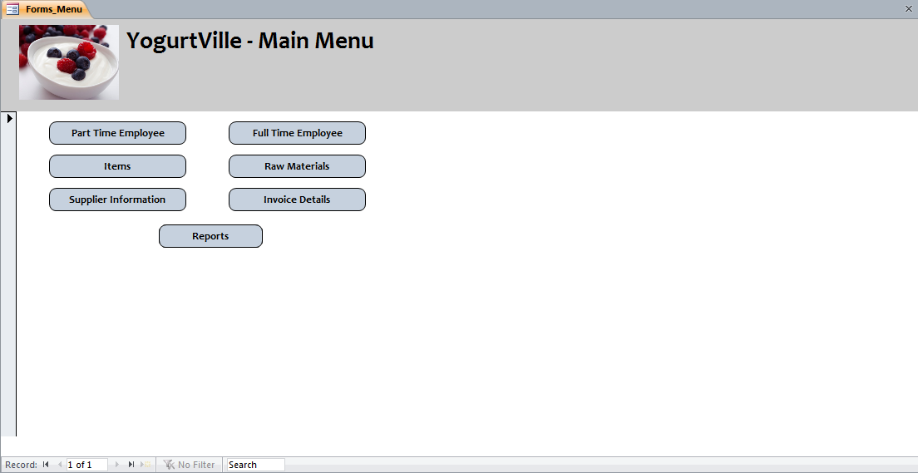

## Item Details Form

Adds details of items that are available to be sold to the database. This form populates the Item table in the database.

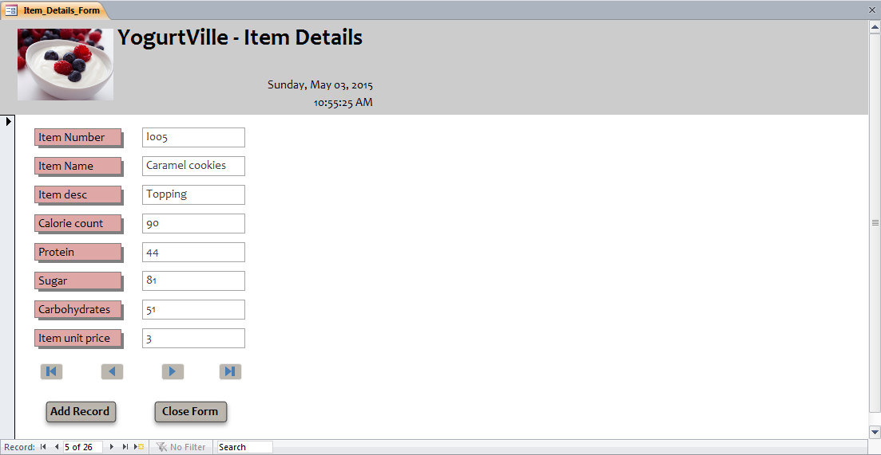

## Fulltime Employees Form

Adds Fulltime employees’ details along with their dependents’ information through a Sub-form. This information gets used for insurance coverage. The form along with its sub-form populates the Employee, Fulltime_Employee and Dependents tables of the database.

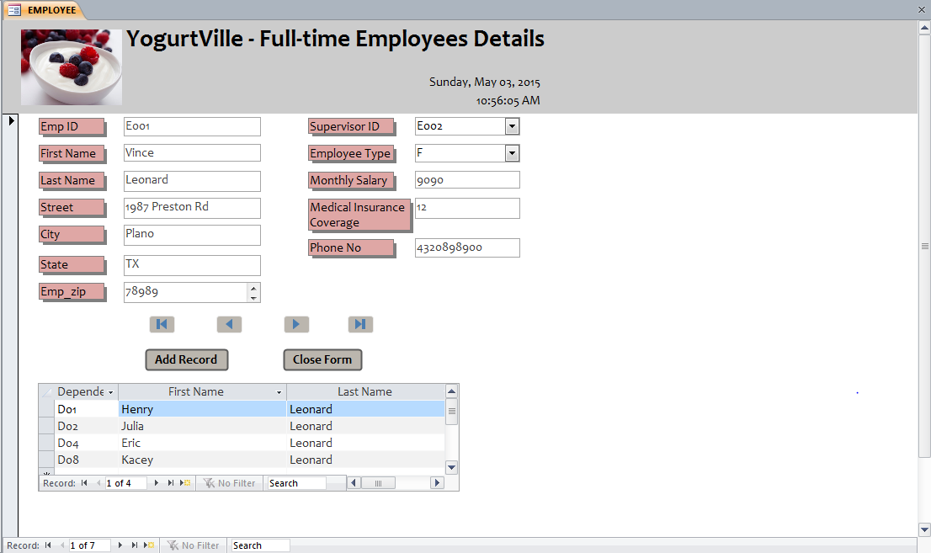

## Part time Employees Form

Adds Part-time Employees’ details to database. The form populates the Employee and Parttime_Employee tables of the database.

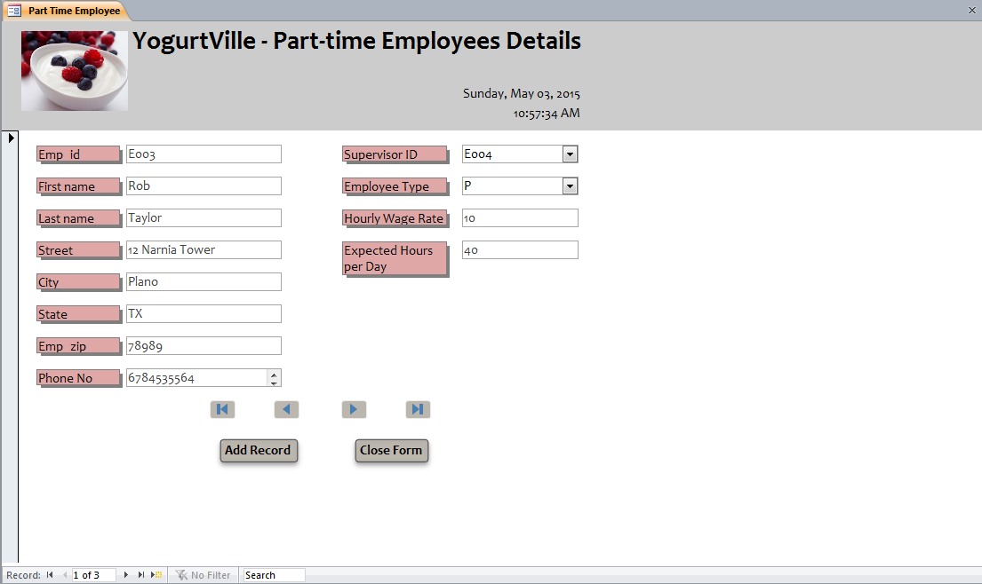

## Raw Material Form

Adds raw material information along with the item numbers which use that particular raw material via sub-form. The form along with its sub-form populates the Inventory and Inventory_Item tables of the database.

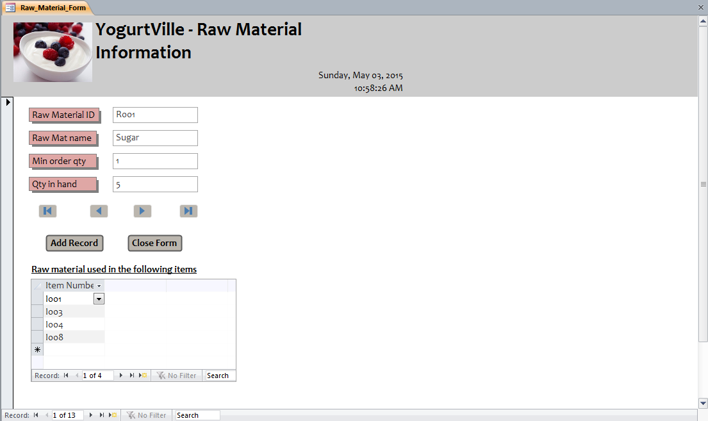

## Supplier Information Form

Adds Supplier information to database. The form populates the Supplier table of the database.

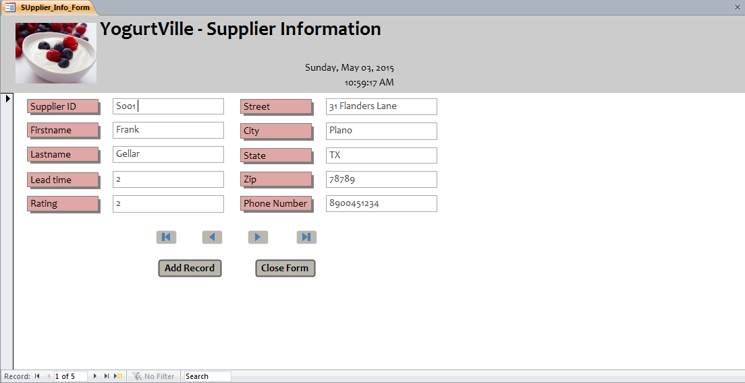

## Invoice Information Form

Adds information about each transaction with a supplier. It adds information about raw material purchased, the supplier from whom the raw material is bought and the employee who handled the transaction and the date of the transaction. The form populates the Inventory_Supplier table of the database.

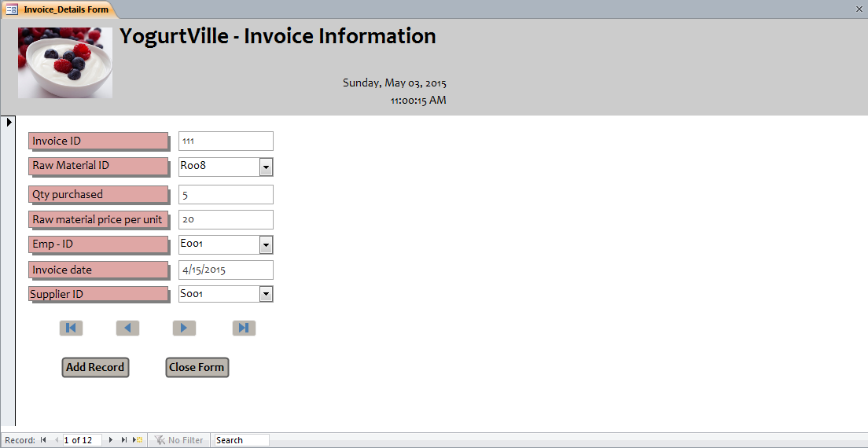

## Report Menu

This is the main menu for various reports Navigation.

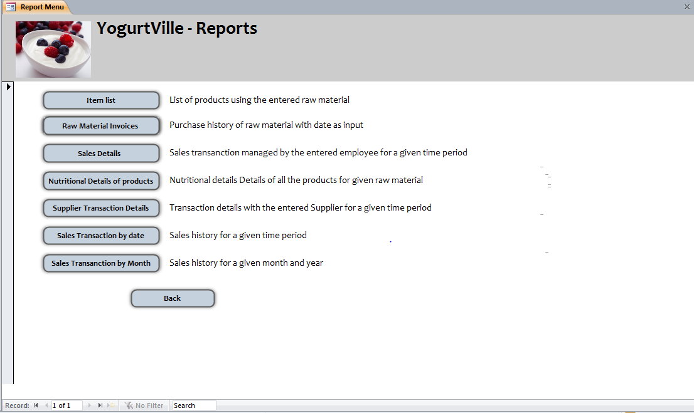

# Sample Reports

## Product Nutritional Value report

This report gives information about Nutritional Value viz. Calorie Count, Sugar Content, Carbohydrates and Protein of all the products.

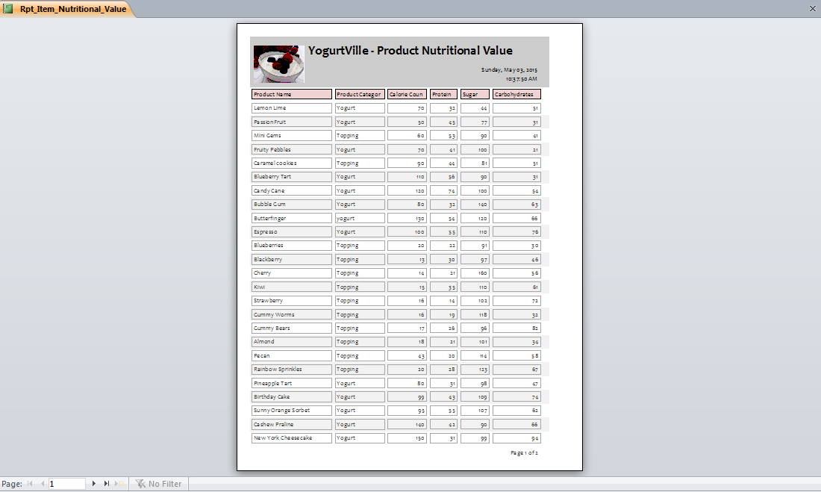

## Raw Material report

This report gives list of items that use the specified raw material as an ingredient. The raw material name is given as an input. The report contains the list of items which use the user specified input raw material in their production process.

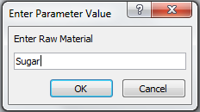

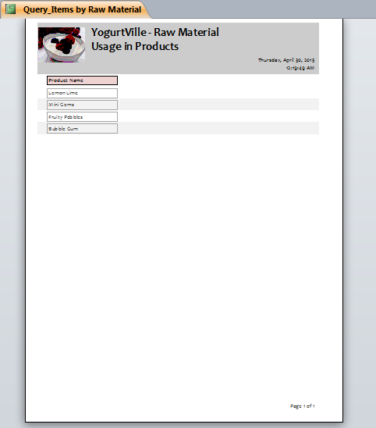

## Raw Material Invoice by Date report

This report gives purchase history of raw materials for a given time period. The start date and end date are given as inputs. The report gives information about the invoice id, invoice date, employee handling the transaction, raw material, quantity purchased (in pounds) and supplier details.

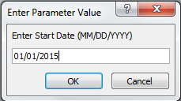

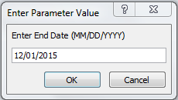

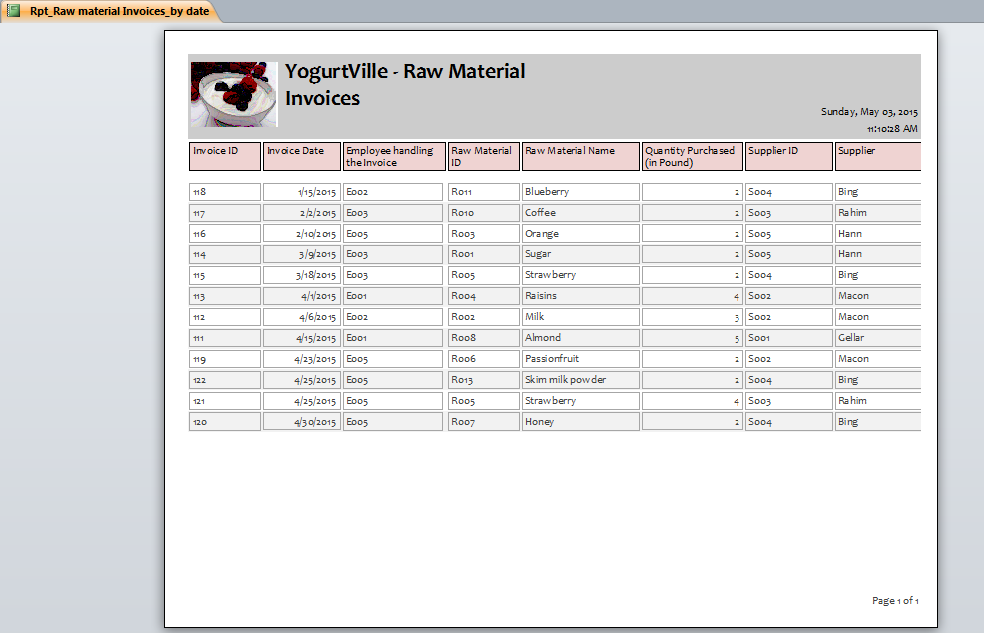

## Raw Material by Supplier report

It gives transaction history of a particular supplier, for a given time period. Supplier ID, start date and end date are given as input. The report contains the invoice id, supplier details like id and name, invoice date, name of the raw material bought from the supplier and the amount paid to the supplier for the transaction.

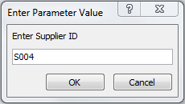

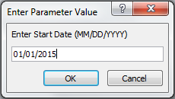

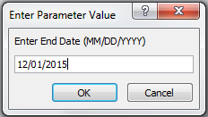

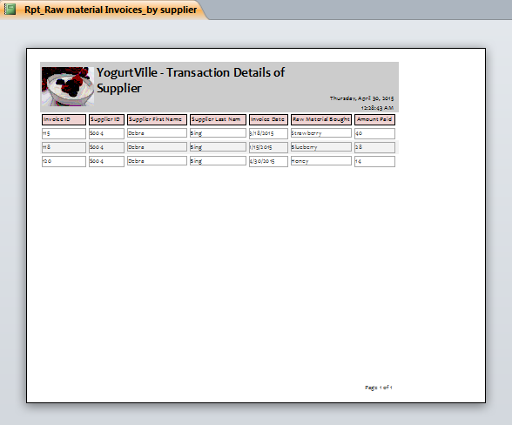

## Sales Details by Date report

This report gives Sales history for a given time period. The start date and end date are given as. The report contains information about Sales transaction, employee handling the transaction, total sales amount.

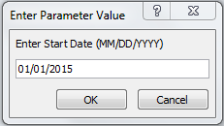

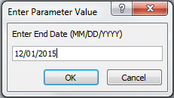

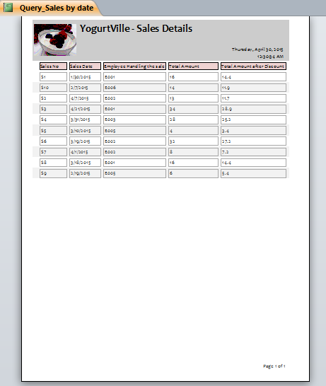

## Sales by Employee report

This report gives details of Sales transactions handled by a particular employee, in a given time period. Employee ID, Start date and End date are given as inputs. The report contains information about Sales and Sales amount generated by the given employee.

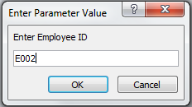

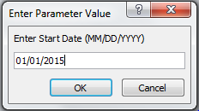

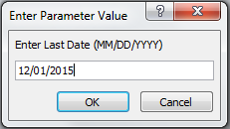

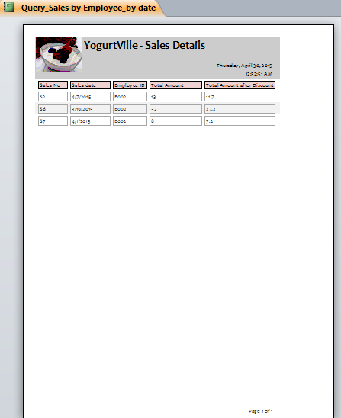

## Sales by Month and Year report

This report gives Sales history for a given month and year. Month and year are given as input. The report contains details of all the sales transaction for a given month and year.

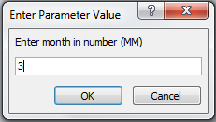

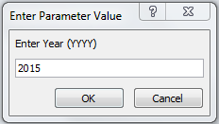

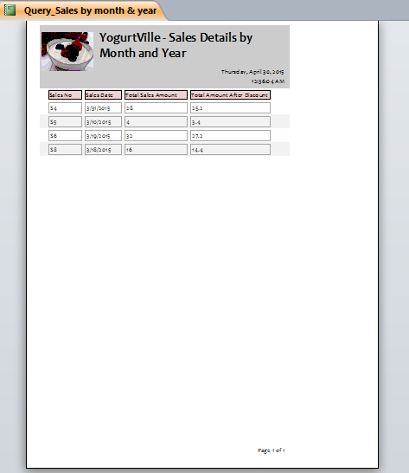

# Contributions

|  |  |
| --- | --- |
| **Task** | **Team Member** |
| Company Background | Rupashree |
| Problems in the Current System | Rupashree |
| Overall Database Design | Team |
| Database Implementation on Access | Mugdha |
| Table Description | Shivroopa |
| ERD diagram on Visio | Mugdha |
| Relational Database Schema | Mugdha |
| Forms | Rupashree & Shivroopa |
| Queries | Team |
| Reports | Rupashree & Mugdha |
| Menus | Shivroopa |
| Testing & Reviewing | Team |
| Final Report Documentation | Shivroopa |